**The Snippets/Evidence of POC**

1. Without math component being used:
   1. **Question**: Can you generate a daily workout routine for me based on my goals
   2. **Profile**: male, 75kg, 175cm, very active, goals: build muscle

**Advice**:

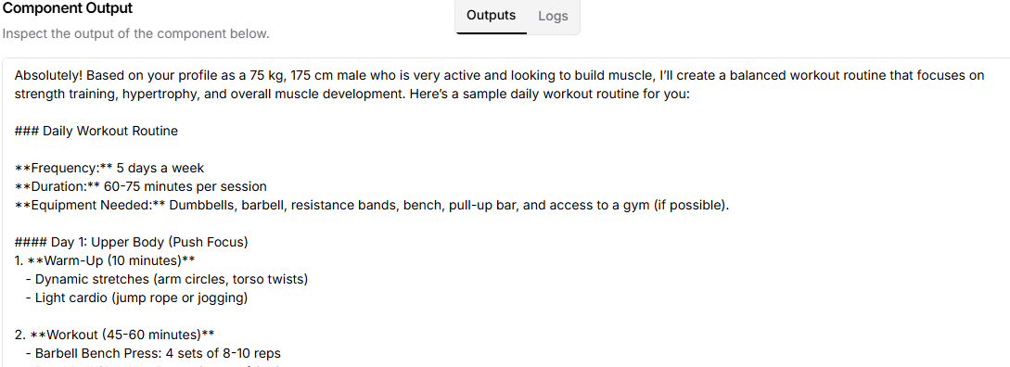

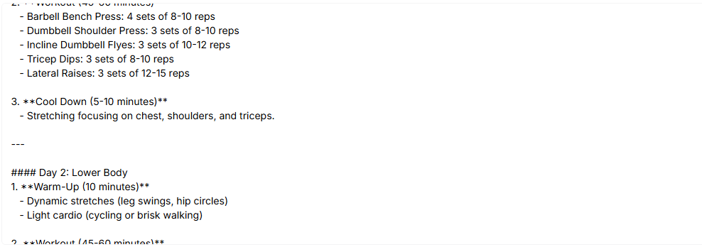

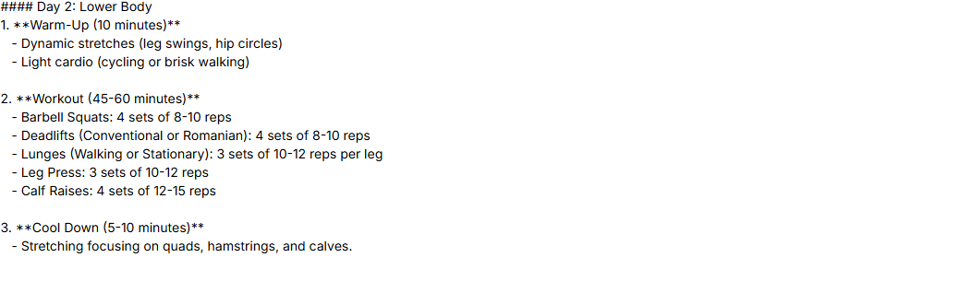

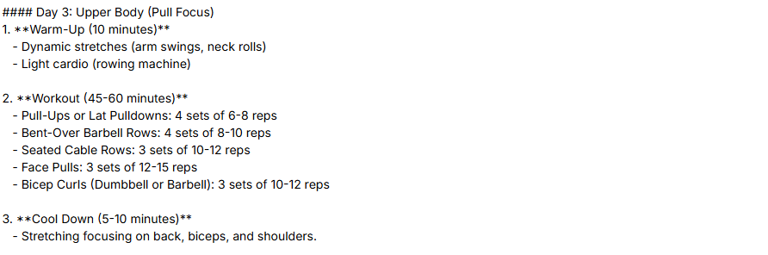

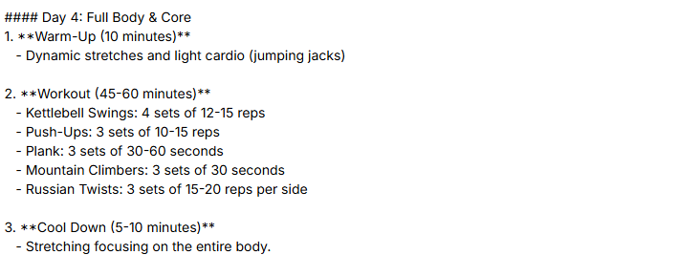

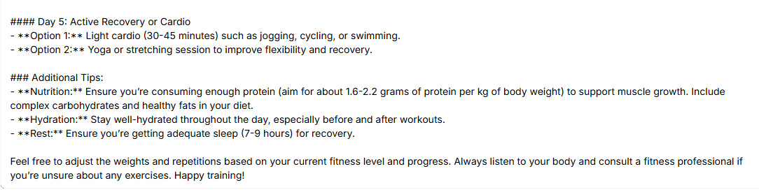

1. With Math component being used:
   1. **Question**: How many calories should I eat each week based on my profile
   2. **Profile**: Same as above

**Advice**:

